3a) Sorter 1 coverage

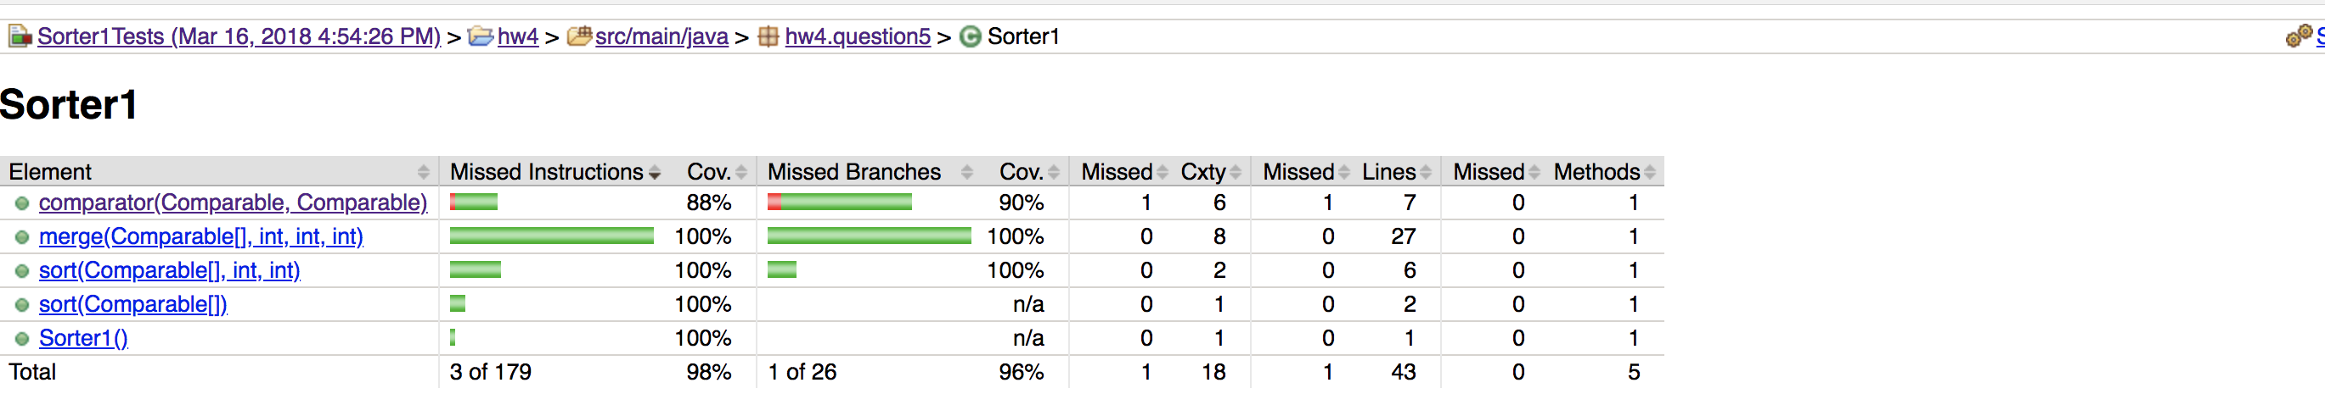

Sorter2 coverage

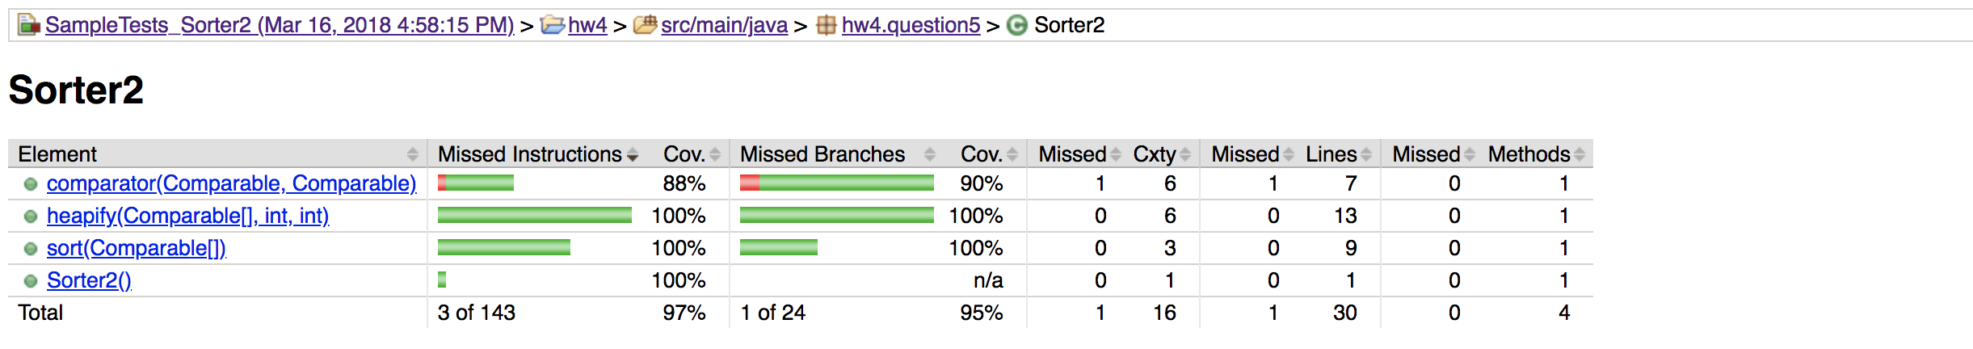

3b) Sorter 1 coverage

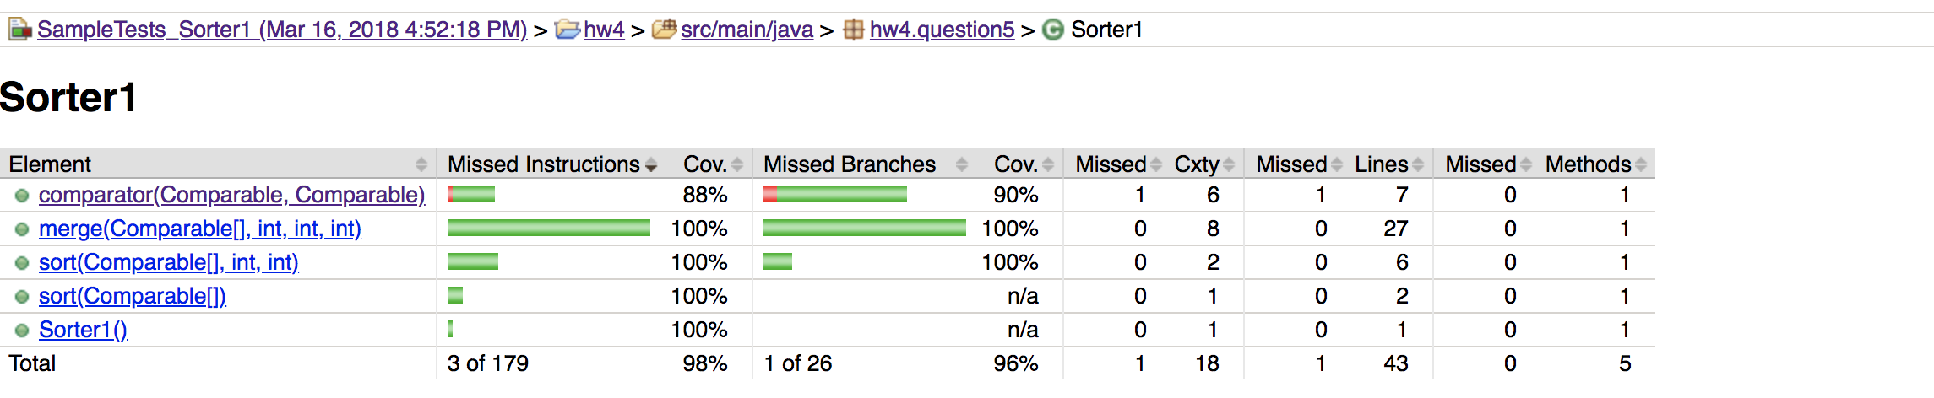

Sorter 2 coverage

